REACT HANDS ON 5

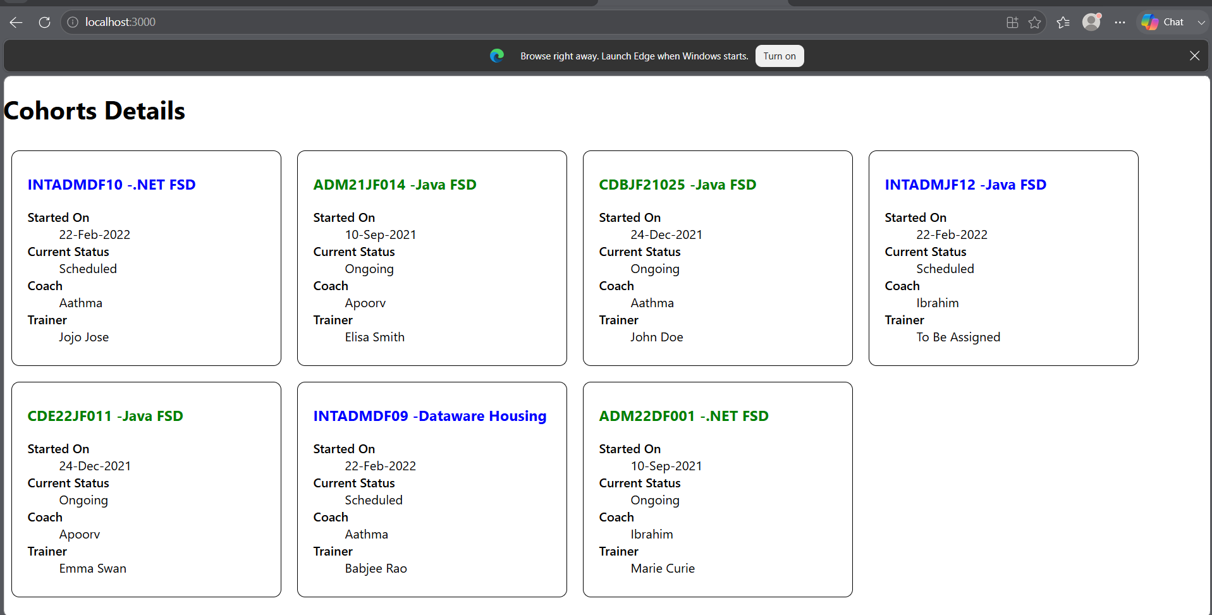

COHORTDETAILS.JS
import styles from './CohortDetails.module.css';

function CohortDetails(props) {
return (
<div className={styles.box}>
<h3
style={{
color:
props.cohort.currentStatus === "Ongoing"
? "green"
: "blue"
}}
>
{props.cohort.cohortCode} -
<span>{props.cohort.technology}</span>
</h3>

<dl>
<dt>Started On</dt>
<dd>{props.cohort.startDate}</dd>

<dt>Current Status</dt>
<dd>{props.cohort.currentStatus}</dd>

<dt>Coach</dt>
<dd>{props.cohort.coachName}</dd>

<dt>Trainer</dt>
<dd>{props.cohort.trainerName}</dd>
</dl>
</div>
);
}

export default CohortDetails;

COHORTMODULES.CSS.JS

.box {
width: 300px;
display: inline-block;
margin: 10px;
padding: 10px 20px;
border: 1px solid black;
border-radius: 10px;
}

dt {
font-weight: 500;
}

